**ST. XAVIER’S COLLEGE**

**(Affiliated to Tribhuvan University)**

Maitighar, Kathmandu



**Database Management System**

**Lab Assignment #3**

**Submitted by:**

PRANESH DHUNJU SHRESTHA  
013BSCCSIT026

**Submitted to:**

|  |  |
| --- | --- |
| **Er. Sanjay Kumar Yadav**  Lecturer  St. Xavier’s College |  |

**Date of Submission:** August 3, 2015

1.ii **Reduced application development time.**

Increase speed of implementing applications: Applications ought to be implemented in less time, since systems development staff can largely concentrate on the processes involved in the application itself rather than on the collection, validation, sorting and storage of data. Much of the data required for a new application may already be held on the database, put there for another purpose. Accessing the data will also be easier because the data manipulation features of the database management system will handle this.

**2. COMPONENTS OF DATABASE SYSTEM**

A database system is composed of four components:

• Data

• Hardware

• Software

• Users

which coordinate with each other to form an effective database system.

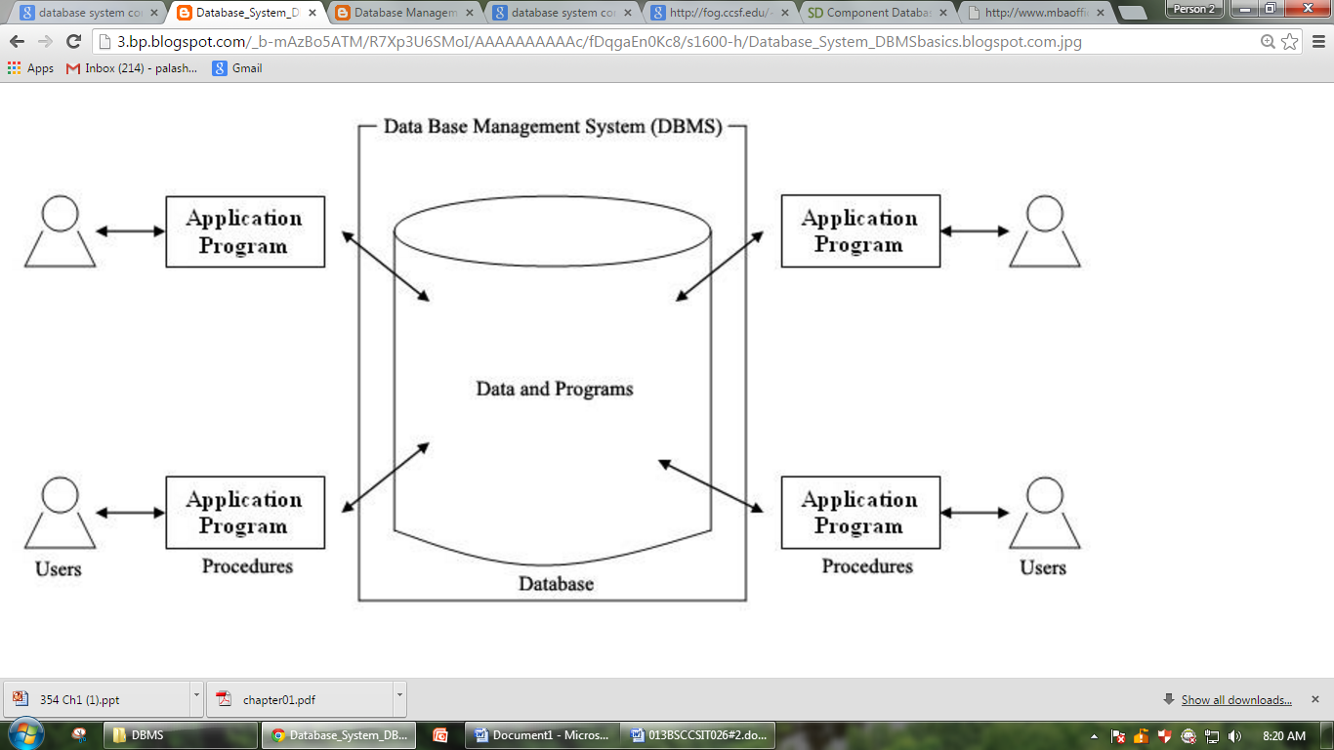

Fig. 1.1 Data Base System

**1. Data** - It is a very important component of the database system. Most of the organizations generate, store and process 1arge amount of data. The data acts a bridge between the machine parts i.e. hardware and software and the users which directly access it or access it through some application programs.

**Data may be of different types.**

• **User Data**- It consists of a table(s) of data called Relation(s) where Column(s) are called fields of attributes and rows are called Records for tables. A Relation must be structured properly.

• **Metadata**- A description of the structure of the database is known as Metadata. It basically means "data about data". System Tables store the Metadata which includes.

- Number of Tables and Table Names

- Number of fields and field Names

- Primary Key Fields

• **Application Metadata**- It stores the structure and format of Queries, reports and other applications components.

**2. Hardware**- The hardware consists of the secondary storage devices such as magnetic disks (hard disk, zip disk, floppy disks), optical disks (CD-ROM), magnetic tapes etc. on which data is stored together with the Input/Output devices (mouse, keyboard, printers), processors, main memory etc. which are used for storing and retrieving the data in a fast and efficient manner. Since database can range from those of a single user with a desktop computer to those on mainframe computers with thousand of users, therefore proper care should be taken for choosing appropriate hardware devices for a required database.

**3. Software**- The Software part consists of DBMS which acts as a bridge between the user and the database or in other words, software that interacts with the users, application programs, and database and files system of a particular storage media (hard disk, magnetic tapes etc.) to insert, update, delete and retrieve data. For performing these operations such as insertion, deletion and updation we can either use the Query Languages like SQL, QUEL, Gupta SQL or application softwares such as Visual 3asic, Developer etc.

**4. Users -** Users are those persons who need the information from the database to carry out their primary business responsibilities i.e. Personnel, Staff, Clerical, Managers, Executives etc. On the basis of the job and requirements made by them they are provided access to the database totally or partially.

**The various types of users which can access the database are:-**

• Database Administrators (DBA)

• Database Designers

• End Users

• Application Programmers

3.The **data communications manager**

(DC manager) is a software component that manages all message transmissions between the user and the DBMS (more accurately, between the user and some application running on top of the DBMS).

**4. Database system utilities.**

In addition to possessing the software modules just described, most DBMSs have database  
utilities that help the DBA in managing the database system. Common utilities have the  
following types of functions:

• **Loading:** A loading utility is used to load existing data files-such as text files or  
sequential files-into the database. Usually, the current (source) format of the data  
ti.le and the desired (target) database file structure are specified to the utility, which  
then automatically reformats the data and stores it in the database. With the proliferation  
of DBMSs, transferring data from one DBMS to another is becoming common in  
many organizations. Some vendors are offering products that generate the appropriate  
loading programs, given the existing source and target database storage descriptions  
(internal schemas). Such tools are also called conversion tools.

**• Backup:** A backup utility creates a backup copy of the database, usually by dumping  
the entire database onto tape. The backup copy can be used to restore the database in  
case of catastrophic failure. Incremental backups are also often used, where only  
changes since the previous backup are recorded. Incremental backup is more complex  
but saves space.

**• File reorganization:** This utility can be used to reorganize a database file into a different  
file organization to improve performance.

**• Performance monitoring:** Such a utility monitors database usage and provides statistics  
to the DBA. The DBA uses the statistics in making decisions such as whether or not to  
reorganize files to improve performance.Other utilities may be available for sorting files, handling data compression,monitoring access by users, interfacing with the network, and performing other functions.

**5.Classification of Database Management Systems:**

There are four structural types of database management systems:

* Hierarchical databases.
* Network databases.
* Relational databases.
* Object-oriented databases

**Hierarchical Databases (DBMS) :**

In the Hierarchical Database Model we have to learn about the databases. It is very fast and simple. In a hierarchical database, records contain information about there groups of parent/child relationships, just like as  a tree structure. The structure implies that a record can have also a repeating information. In this structure Data follows a series of records, It is a set of field values attached to it. It collects all  records together as a record type. These record types are the equivalent of tables in the relational model, and with the individual records being the equivalent of rows. To create links between these record types, the hierarchical model uses these type Relationships.

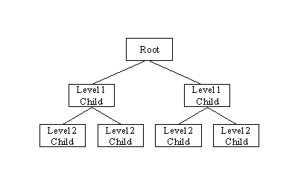  
fig : hierarchical database.

**Network Database:**A network databases are mainly used on a large digital computers. It more connections can be made between different types of data, network databases are considered more efficiency It contains limitations must be considered when we have to use this kind of database. It is Similar to the hierarchical databases, network databases .Network databases are similar to hierarchical databases by also having a hierarchical structure. A network database looks more like a cobweb or interconnected network of records.

In network databases, children are called members and parents are called occupier. The difference between each child or member can have more than one parent.

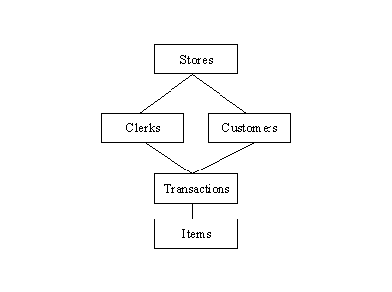

**Relational Databases :**

In relational databases, the relationship between data files is relational. Hierarchical and network databases require the user to pass  a hierarchy in order to access needed data. These databases connect to the data in different files by using common data numbers or a key field. Data in relational databases is stored in different access control tables, each having a key field that mainly identifies each row. In the relational databases are more reliable than either the hierarchical or network database structures. In relational databases, tables or files filled up with data are called relations (tuples) designates a row or record, and columns are referred to as attributes or fields.

Relational databases work on each table has a key field that uniquely indicates each row, and that these key fields can be used to connect one table of data to another.

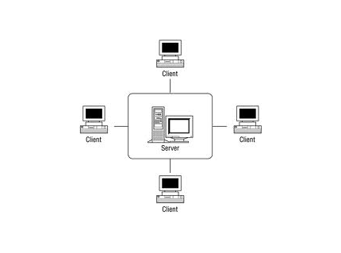

**The relational database has two major reasons:**

1. Relational databases can be used with little or no training.
2. Database entries can be modified without specify the entire body.

**Object-Oriented Model :**

In this Model we have to discuss the functionality of the object oriented Programming .It takes more than  storage of programming language objects. Object DBMS's increase the semantics of the C++ and Java .It provides full-featured database programming capability, while containing native language compatibility. It adds the database functionality to object programming languages.This approach is the analogical of the application and database development into a constant data model and language environment. Applications require less code, use more natural data modeling, and code bases are easier to maintain. Object developers can write complete database applications with a decent amount of additional effort.

The object-oriented database derivation is the integrity of object-oriented programming language systems and consistent systems. The power of the  object-oriented databases comes from the cyclical treatment of both consistent data, as found in databases, and transient data, as found in executing programs.

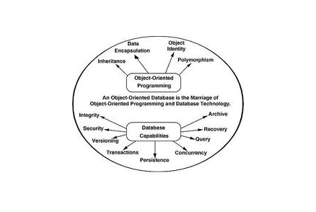

**7. Database Lifecycle**

The database lifecycle includes database creation and resource allocation, managing the database schema and data, performing backup and recovery tasks, and decommissioning databases. Database administrators and application developers perform the database lifecycle tasks.

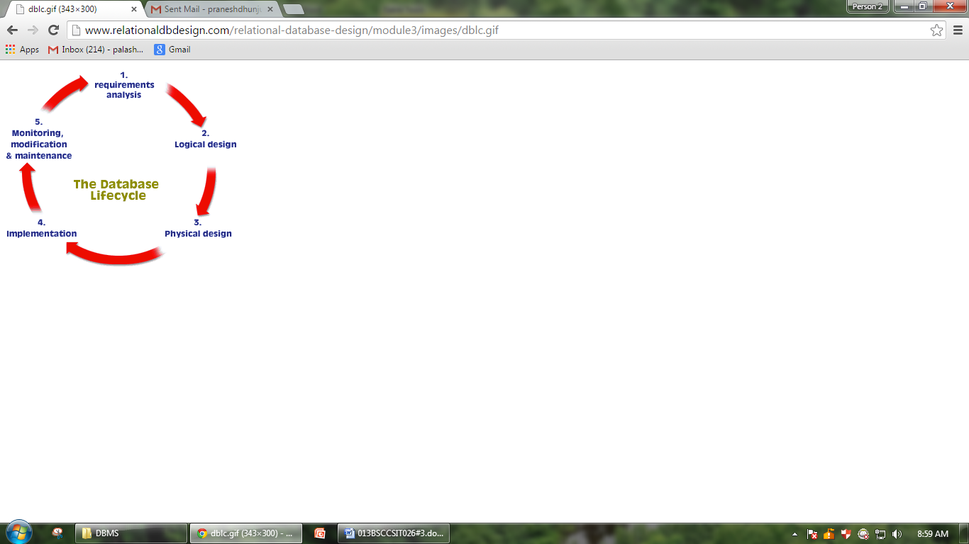

|  |  |
| --- | --- |
| **Create** | Create and allocate resources to a new database using database configuration templates. Database templates specify sets of database parameters, including resource limits. Application developers can perform do-it-yourself database creation using the templates. See [Requirements for Creating Databases](http://pubs.vmware.com/datadirector/topic/com.vmware.datadirector.admin.doc/GUID-61FFC346-DE6F-400D-A961-0D45796AFE7F.html#GUID-61FFC346-DE6F-400D-A961-0D45796AFE7F).  Administrators can grant permissions to their users that enable the users to create databases from templates, but do not allow them to modify the templates or change the default resource allocations. This restriction provides resource limit enforcement and allows administrators to retain control of resource and security policies. See [Managing Database Templates](http://pubs.vmware.com/datadirector/topic/com.vmware.datadirector.admin.doc/GUID-20699DA4-15DF-4F88-B8D1-11AFC0AB4F49.html#GUID-20699DA4-15DF-4F88-B8D1-11AFC0AB4F49). |
| **Manage schema** | Manage the database schema and add data. You can create tables, designate primary and foreign keys and indexes, and create views, sequences, triggers, and other database entities. |
| **Backup and restore** | Safeguard your data by taking regular backups and testing your backups. See [Safeguarding Data](http://pubs.vmware.com/datadirector/topic/com.vmware.datadirector.admin.doc/GUID-A9946901-B2A5-4B55-B208-A33F214123FA.html#GUID-A9946901-B2A5-4B55-B208-A33F214123FA). |
| **Clone** | Ensure access to consistent, yet isolated databases by cloning the database for specific purposes such as development or quality assurance. See [Cloning Databases](http://pubs.vmware.com/datadirector/topic/com.vmware.datadirector.admin.doc/GUID-58127A38-A6F2-4F74-946D-59248F1DFDE3.html#GUID-58127A38-A6F2-4F74-946D-59248F1DFDE3). |
| **Scale up** | Dynamically increase the database size as required, during the development, test, and production phases. |
| **Monitor performance and usage** | Use the Data Director user interface to monitor tasks and events. See [Monitoring the Data Director Environment](http://pubs.vmware.com/datadirector/topic/com.vmware.datadirector.admin.doc/GUID-D88EA818-12FA-46B4-8294-D23545D1CE42.html#GUID-D88EA818-12FA-46B4-8294-D23545D1CE42). |
| **Stop and restart the database** | Stop and restart, for example, to perform maintenance tasks. |
| **Decommission the database** | Disable and then delete databases. Free up the resources when they are no longer needed. |

Every database requires a database owner account that can perform all schema management operations. This account is specific to the database and cannot log in to Data Director. You can add database owner accounts after database creation. Data Director users must log in with their database-specific credentials to view the database, its entities, and its data or to perform database management tasks.

Database administrators and application developers can manage databases only if they have appropriate permissions and roles granted to them by the organization administrator. The permissions and roles must be granted on the database group or on the database, and apply only within the organization in which they are granted.

**Reference**

1. <http://dbmsbasics.blogspot.com/2008/02/database-system-and-its-components.html>
2. <http://database-management-systems.blogspot.com/2009/09/database-system-utilities.html>
3. <http://www.c-sharpcorner.com/UploadFile/65fc13/types-of-database-management-systems/>
4. Additional advantages of DB approach.
5. expandability/flexibility
6. Reduced application development time.
7. Economy of scale
8. Centralized control by the DBA.
9. Database system component.
10. Data
11. Hardware
12. Software
13. Users
14. Data communication manager
15. Database system utilities.
16. Classification of dbms
17. Variation of distributed environment
18. Database lifecycle.